Lpp. 273 №7

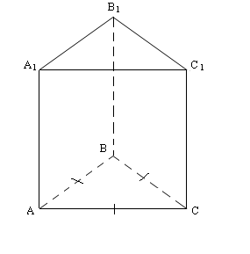
Dots:

ABC- regulārs trījstūris
AB=5 cm.
S_{(sānu)} = 2S_{(pam.)}

Jāaprēķīna:

V -?

Atrisinājums:

V=S_{(pam)} * H
S_{(pam)=} $\frac{a^{2}\sqrt{3}}{4}=\frac{\text{25}∗\sqrt{3}}{4}$_{(cm}²₎

(a=AB=5cm.)

S(sānu)= P_{(pam)}*H

H=$\frac{S(\text{sanu})}{P(\text{pam})}$
S_{(sānu)}=2S_{(pam)} = $\frac{2∗\text{25}\sqrt{3}}{4}=\frac{\text{25}\sqrt{3}}{2}$(cm²)

P(pam)= 5+5+5= 15 (cm)

H= $\frac{\frac{\text{25}\sqrt{3}}{2}}{\text{15}}=\frac{\text{25}\sqrt{3}}{\text{30}}=\frac{5\sqrt{3}}{6}$(cm)

V=$\frac{\text{25}\sqrt{3}}{4}⋅\frac{5\sqrt{3}}{6}=\frac{\text{125}⋅3}{\text{24}}=\frac{\text{125}}{8}=\text{15}\frac{5}{8}$(cm³)

Atbilde: V= $\text{15}\frac{5}{8}$ cm³

Lpp. 273 №8

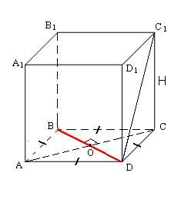
Dots:

ABCD-rombs
AB=4 cm
AC-diagonāle, AC= $4\sqrt{3}$cm
DC₁-prizmas sānu skaldnes diagonāle ; DC₁=$2\sqrt{\text{31}}$сm

Jāaprēķīn:

V-?

Atrisinājums:

V=S(pam)*H

AO=OC, BO=OD (romba diagonāles īpašība)=>AO=OC= $\frac{4\sqrt{3}}{2}=2\sqrt{3}$ (cm)

leņķis AOB=90° (romba diagonāles īpašība) =>
Pēc Pitagora teorēmas:

BO²=AB²-AO²
BO²=4²- ($2\sqrt{3}$)²
BO= $\sqrt{\text{16}−\text{12}}$
BO=$\sqrt{4}$
BO= 2( cm)

BD=2BO=2*2=4 (cm)

S(pam)=$\frac{1}{2}$ ABCD=$\frac{1}{2}⋅4⋅4\sqrt{3}=\frac{4⋅4\sqrt{3}}{2}=2⋅4\sqrt{3}=8\sqrt{3}$(cm²)

∆DC₁C - taisnleņķa trijstūris
Pēc Pitagora teorēmas:
H²=DC₁² –DC²
H²= ($2\sqrt{\text{31}}$)² - 4²
H²= 4*31-16
H=$\sqrt{\text{124}−\text{16}}$
H=$\sqrt{\text{108}}$
H=$\sqrt{4⋅9⋅3}$
H= $6\sqrt{3}$(cm)

V=$8\sqrt{3}⋅6\sqrt{3}=\text{48}⋅3=\text{144}$(cm³)

Atbilde: V= 144 cm³

